Name:_______________________________________________DOB:____________________________
Address:______________________________________________________________________________
City:______________________________________ State:______________________________________ Zip:_______________________________________
Home Phone:_______________________________Cell Phone:____________________________________
Email Address:___________________________________________________________________________
Referred by:__________________________Occupation:__________________________________________
In case of emergency:____________________________________Phone:_____________________________

Massage Treatment Intake

Have you had a professional massage before?___________How recently?_____________________________

Circle the primary purpose of today's visit?
Pain relief Relaxation Therapeutic PIP Other___________
Any injuries in the past two years?_________
If yes where were the injuries located and when?_________________________________________________
Other medical condition? If yes please list them:__________________________________________________
Are you taking Blood Thinners or any other medicatioins? If yes please list them:____________________________________________________________________________________

Please circle any symptoms/conditions that are current or have been present in the last six months: Stress
Headaches Pregnancy Arthritis High Blood Pressure Varicose veins Contagious diseases Allergies Back pain Heart disease Head cold Breathlessness Abdominal pain Digestion Issues Other______________________________________________________________________

Please mark any areas of tension below
FEMALE MALE
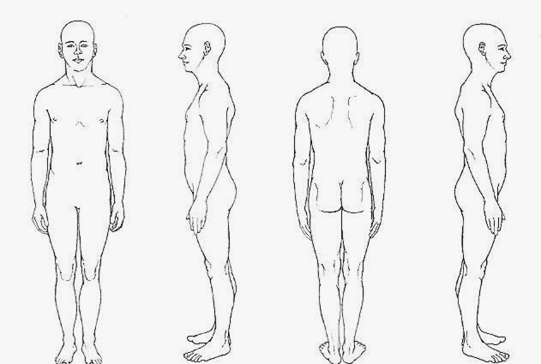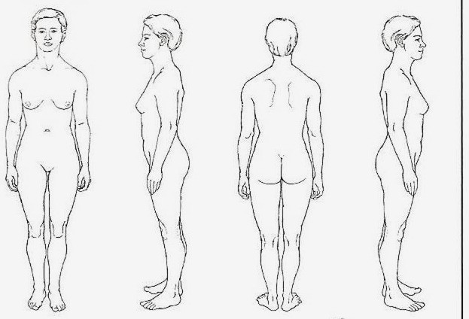
Cirlce one: 0- No Pain 1-2-Mild 3-4-Nagging 5-6-Distressing 7-8-Horrible 9-10-Worst Possible

I understand that massage practitioners do not diagnose illness, disease, or any physical or mental disorder; nor do they prescribe medical treatment or perform spinal manipulations. I acknowledge that massage is not a substitute for medical examination or diagnosis and that it is recommended that I see a primary health care provider for that service. I have stated all known medical conditions and will update the massage practitioner in writing of any changes in my health status if necessary.
Signed: _______________________________________________ Date: __________________________
(Client or responsible party)

